The ulearn calendar tool displays a consolidated view of course events (i.e.,

assignment due dates across courses) as well as personal events. It provides the

ability to customize the display for each user.

# Instructions:

1. On the left-hand navigation menu, click on **Calendar.** The ulearn Calendar will automatically display your schedule.

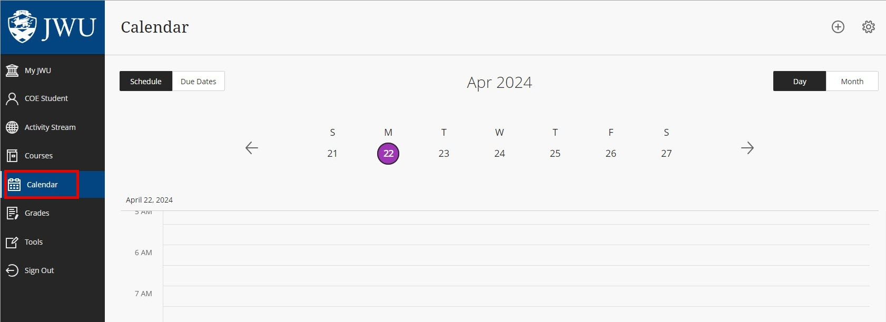

ALT TEXT: Calendar button on the left-hand navigation menu is highlighted

1. Students can switch to the **Due Dates** view in the top left corner.

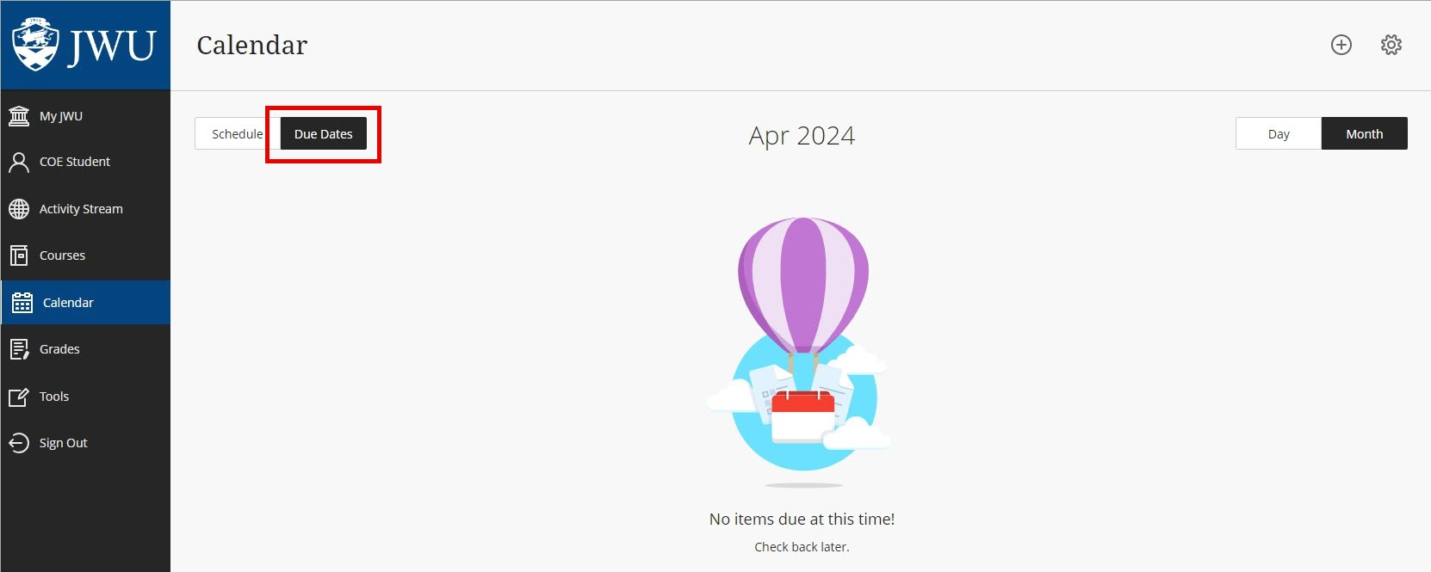

ALT TEXT: Due dates button is highlighted.

1. Students can also switch between the **Day** view or the **Month** view in the top right corner.  
   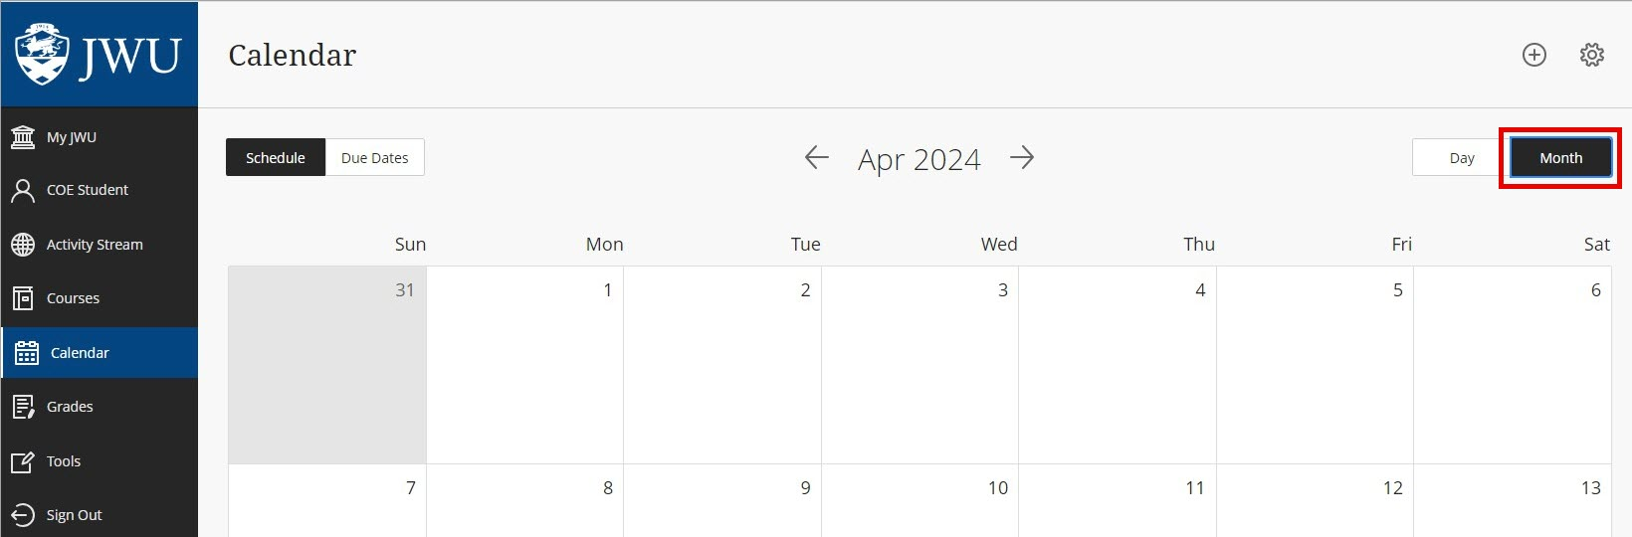

ALT TEXT: Month button in the top right corner is highlighted.

1. Click on the **Settings** icon (top right of the calendar) to select the calendars you want to view to customize the display. Students can select all, clear all or checkmark the ones that you would like to see on your display.

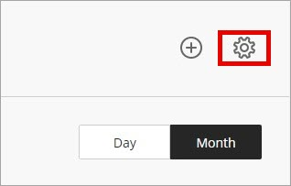

ALT TEXT: Settings icon is highlighted.

1. Students can add events to personal calendars by clicking the **Plus** sign (top right of

calendar) or by selecting a specific date to create a new event.

In the Create Event window, provide an event name, select the calendar, set a

date and time and provide a description for the new event.

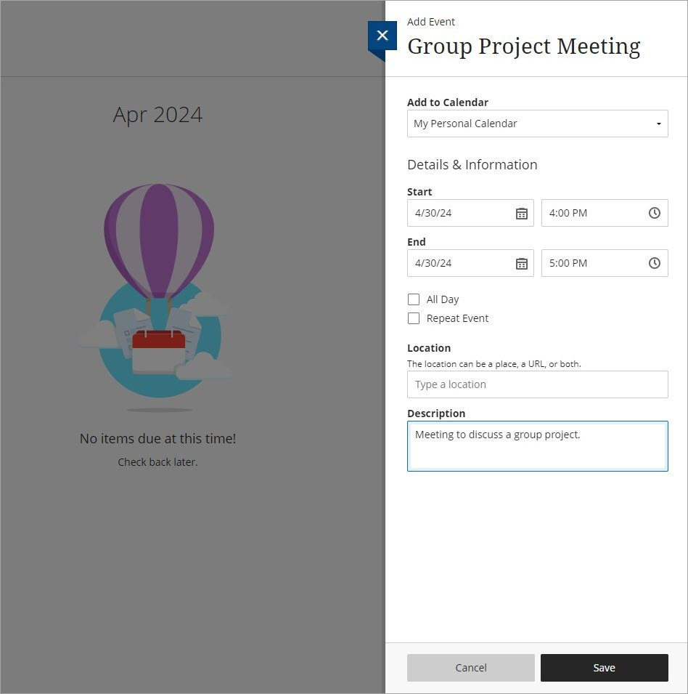

ALT TEXT: Group project meeting window open, start date and end date are selected and description states: Meeting to discuss a group project.