This guide will outline options for ulearn notifications, including email, the activity stream, and push notifications, and review how to adjust the default settings according to your preferences.

# Instructions

1. **Navigate** to Blackboard and **log in** by clicking on the big yellow button.  
   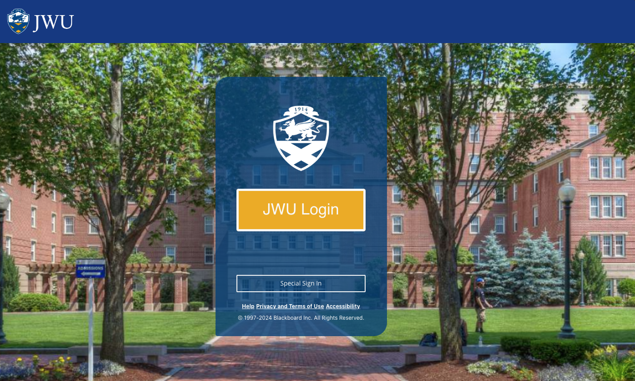

*Alt text: JWU ulearn login page.*

1. In the lefthand navigation column, **select** your profile (your name and a picture of a person from the shoulders up

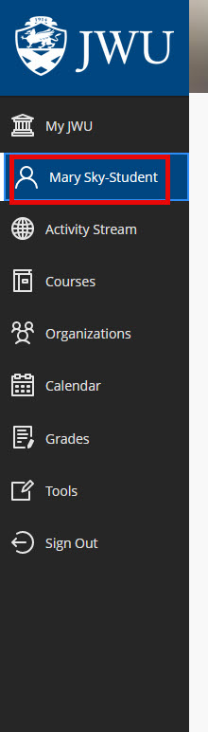

*Alt Text: In the lefthand navigation column, select your profile (your name and a picture of a person from the shoulders up).*

1. Under “System Settings,” **select** the pencil icon next to each "notifications" link to change how you are alerted and about what activity in ulearn.
   1. Click the pencil icon next to “Stream notifications” on the left-hand navigation panel in ulearn to change how you are alerted in your activity stream.
   2. Click the pencil icon next to “Email notifications” to change how you are alerted via email.
   3. Click the pencil icon next to “Push notifications” to change how you are alerted via the bell icon in the top corner of the screen.

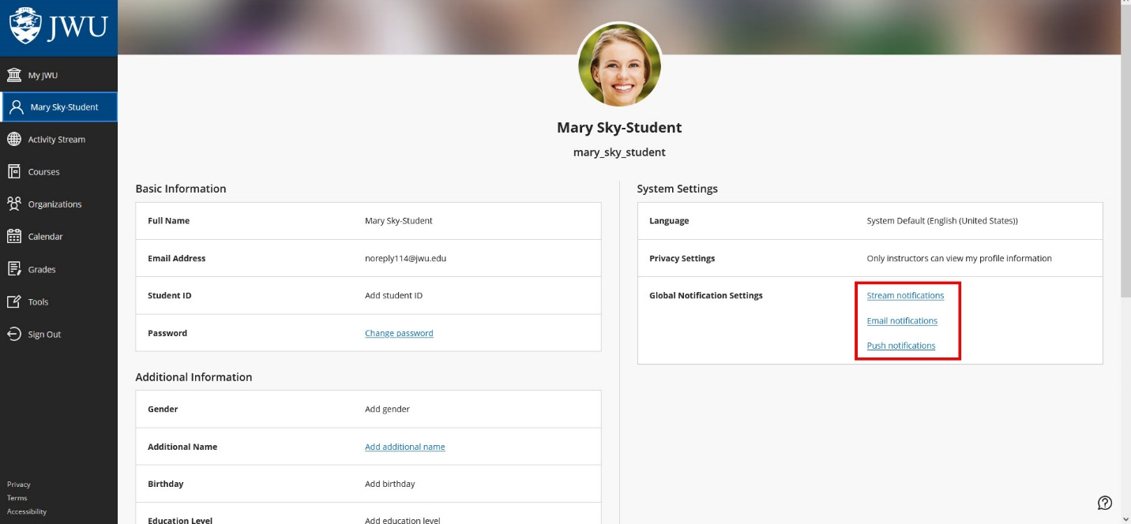

*Alt text: Stream notifications, Email notifications, and Push notifications are highlighted in the system settings area of a user profile in ulearn.*

1. Once the pencil icon is clicked, “Notification Settings” should appear on the right side of the screen. A visible green checkmark indicates a notification or notification group is on.
2. To turn a notification off, **click** the green check mark once so it is no longer visible. To turn a notification on, click the box again.

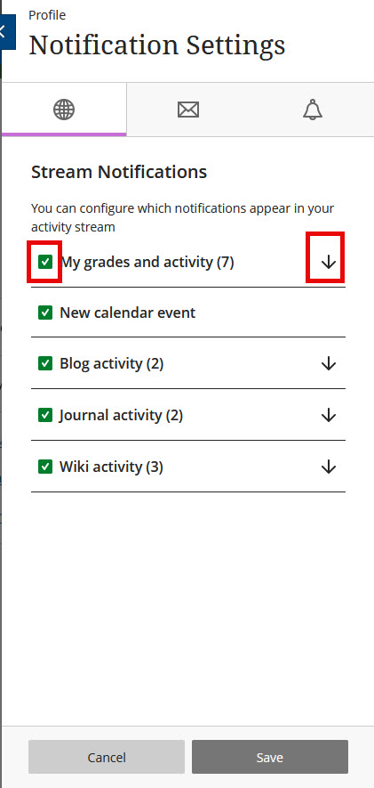

*Alt text: A visible green checkmark indicates a notification or notification group is on.*

1. To turn a notification off, click the green check mark once so it is no longer visible. If all notifications in a category are turned off, the top box and all other boxes will be empty and white.

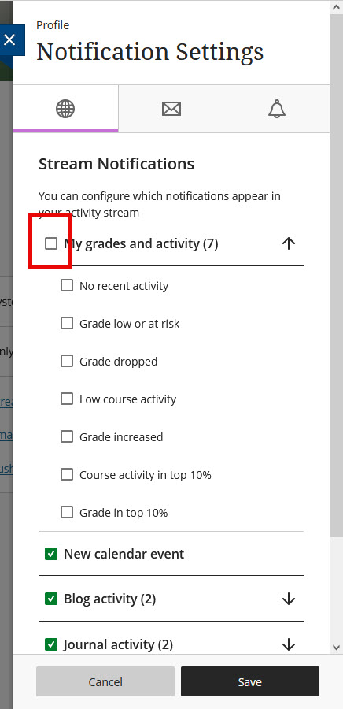

*Alt Text: To turn a notification off, click the green check mark once so it is no longer visible.* If all notifications in a category are turned off, the top box and all other boxes will be empty and white.

1. To turn on or off notifications by type, such as “Student Alerts,” click the box next to the category name. To turn on or off individual notifications within each category, click the down arrow next to the list of categories and click the box next to each notification.
2. If some notifications in a category are on and some are off, the category will have a green line in the box next to it, indicating that it contains both active and inactive notifications. The notifications within that category will be green with check marks, indicating that they are active.

*Alt Text:* *If some notifications in a category are on and some are off, the category will have a green line next to it, and the notifications within that category will be green with check marks.*

1. If all notifications within a category are on, a green checkmark will appear next to each category and individual notification option within that category.
2. Once you have adjusted your notification preferences, **click** the 'Save' button located in the bottom left corner of the 'Notification Settings' window to save your changes.

*Alt Text:* *Once you have adjusted your notification preferences,* ***click*** *the 'Save' button located in the bottom left corner of the 'Notification Settings' window to save your changes.*