This userguide will show you how to choose how courses are displayed in the ulearn dashboard.

Instructions

- Log in to ulearn.

- Click on Courses

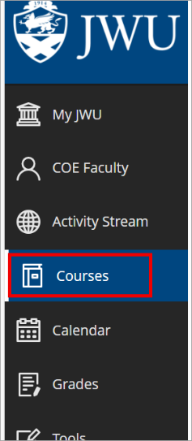
ALT TEXT: ulearn left side navigation menu with Courses highlighted

- Courses for the current term are listed by default.

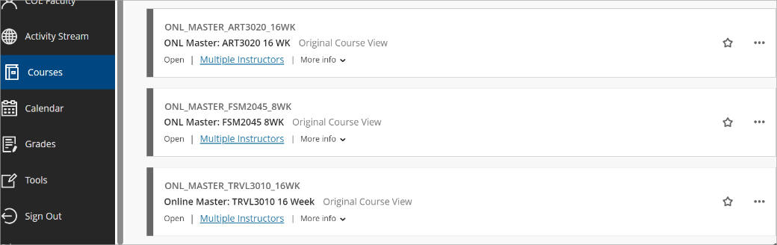
ALT TEXT: List of courses

- Click the display icon to view course as a list or as tiles.
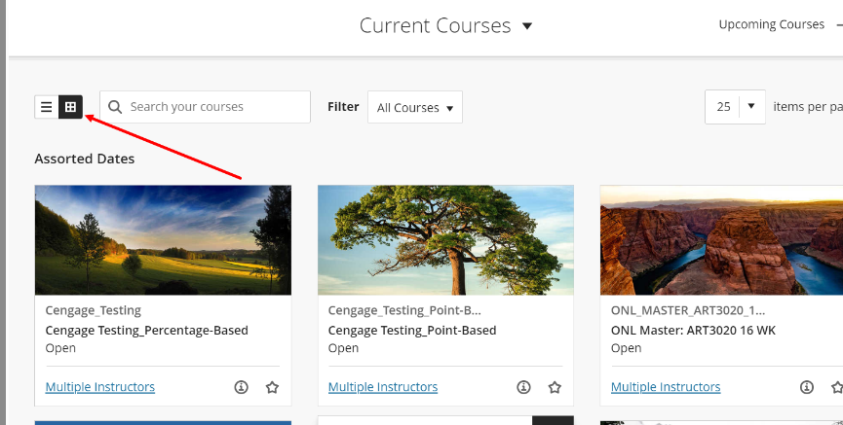
ALT TEXT: Display icon highlighted

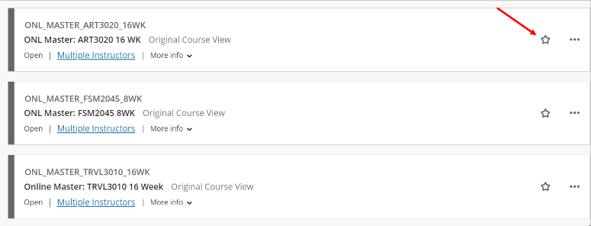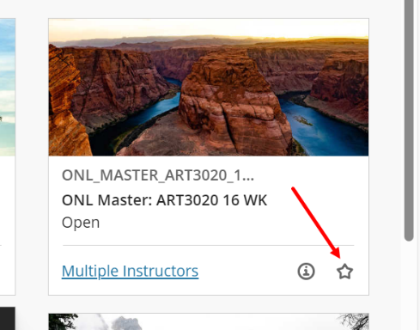
Note:
You can add courses to Favorites by clicking on the star. Selected courses will appear at the top of the page.
ALT TEXT: Favorites icon highlighted

