  - The ulearn homepage provides a streamlined experience for accessing your course sites, grading tasks, and other ulearn tools.

Instructions

- After logging in to ulearn, your list of courses is visible. Click the icons above your courses to switch between list and tile view.
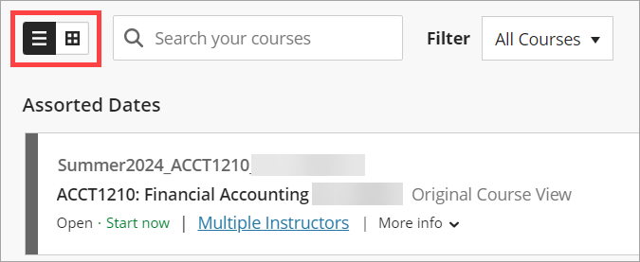
ALT Text: List of courses with course display icons highlighted.
Note: Any course marked Private is unavailable to students. You can still access and work in these course sites.

- To view courses from a different term, click the down arrow next to Current Courses and select the term from the drop-down menu.
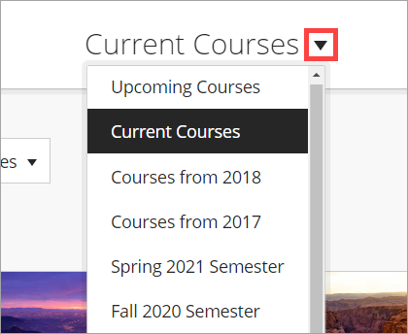
ALT Text: Down arrow selected next to Current Courses. The drop-down menu of additional course terms is expanded.
Alternately, you can use the left and right arrows on either side of Current Courses to browse through the different terms.
ALT Text: The left and right arrows on either side of Current Courses are highlighted.
Note: Only online courses will appear on the Upcoming Courses list because they’re automatically made available to students. If you’re teaching an upcoming on-campus course, it will appear on your Current Courses list.

- Use the Search your courses box to easily locate courses within the term you’re currently viewing. Type a keyword from the course ID or course name (e.g., ACCT1210) into the box.
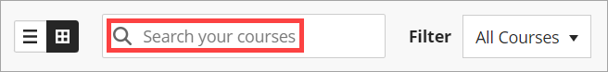
ALT Text: Search your courses box is highlighted.
To remove the filter, click the X in the Search your courses box to return to your full list of courses for the selected term.
ALT Text: The X option in the Search your courses box is highlighted.
- You can Favorite a course so it shows at the top of the list within the term you’re currently viewing by clicking the Star icon to the right of the course list entry or below the course tile. To remove a course from your list of favorites, click the highlighted Star icon to remove it.
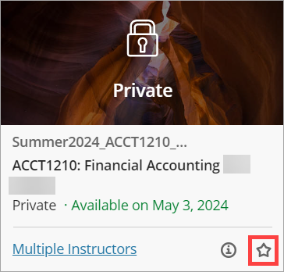
ALT Text: The Star icon selected next to a course.
- Click on a course list entry or tile to open the course site.
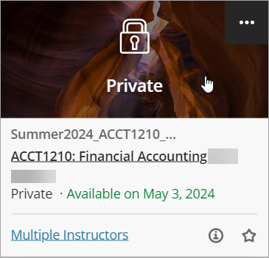
ALT Text: A course tile with a cursor on it.

- View and work in the course site as usual. When you’re ready to return to the ulearn homepage, click the X in the upper left corner or anywhere on the ulearn homepage menu that is partially hidden behind the course site.
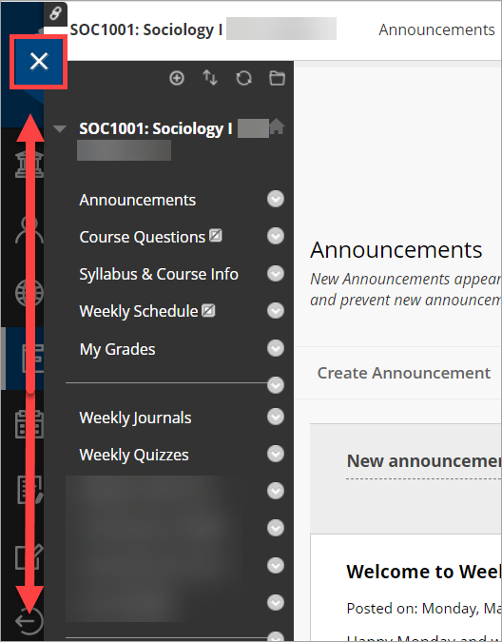
ALT Text: The X icon selected in the upper left of a course site. An arrow indicating where to click on the partially hidden navigation menu.
- Use the left navigation menu on the ulearn homepage to access ulearn features.
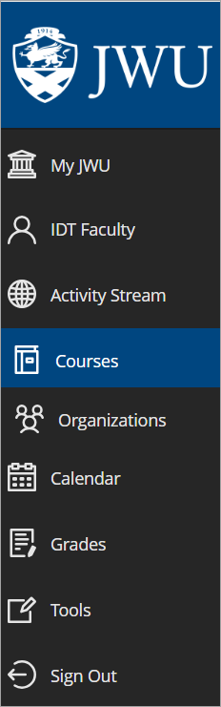
ALT Text: The left ulearn homepage navigation menu with the following options: My JWU, IDT Faculty, Activity Stream, Courses, Organizations, Calendar, Grades, Tools, and Sign Out.

My JWU: Access this area for links to common resources (e.g., Taskstream, Kaltura My Media).

Profile: Click your name to access your ulearn user profile. You can add or edit your ulearn avatar on this page.

Activity Stream: Use this page to see what’s new in all your courses (e.g., new discussion posts, new student submissions) and what needs attention. You can jump directly into course activities from the list. The Activity Stream page also allows you to change your notification settings.

Courses: Return to the list of ulearn courses you’re enrolled in.

Organizations: Access the list of ulearn organizations you’re enrolled in. If you’re not enrolled in any organizations, you won’t see this option on the navigation menu.

Calendar: Use the global calendar to see upcoming due dates from all your courses.

Grades: Navigate to the Grades page to see grading tasks and a grading summary for each of your courses. You can begin grading right from this page.

Tools: Access systemwide tools from this area (e.g., Taskstream, Kaltura My Media).

Sign Out: Click the Sign Out button to log out of ulearn.

