  - Courses you are enrolled in will appear in your ulearn dashboard. You can choose how these courses are displayed.

Instructions:
- Click Courses at the left side navigation once you’ve logged into ulearn.
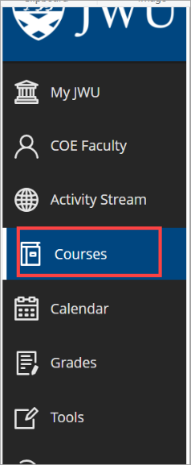
ALT TEXT: Left side navigation menu with Courses highlighted

- Your courses for the current term are listed. Click on the display icon to view them as a list or as tiles.
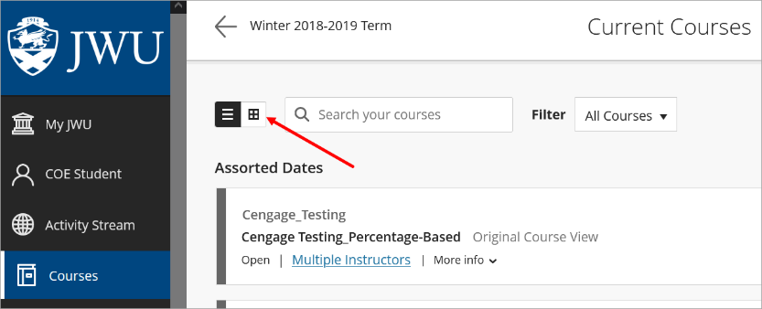
ATLT TEXT: Course display icon
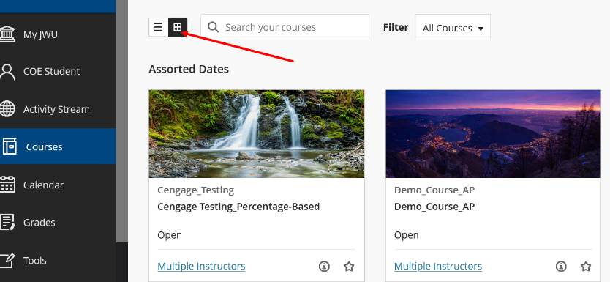
ALT TEXT: Course display icon
- Click the star to add a course to favorites. Selected course will display at the top of the dashboard.
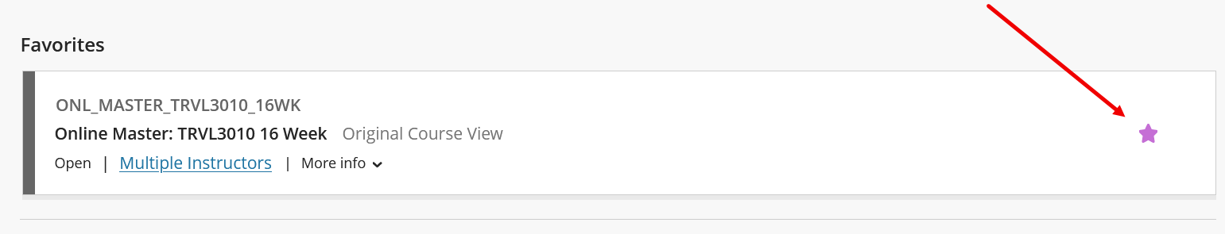
ALT TEXT: Favorites icon
Note:
Course sites for on-campus courses are not available until the instructor makes them available. If you don’t see your course in ulearn, contact your instructor.
Courses that are taught fully online are automatically available in ulearn three days before the semester starts.

