On the ulearn My Grades page, you can view all course assignments and grades for the course you are in, including any assignment due dates and all comments instructors leave on graded assignments.

# Instructions:

1. Go to ulearn and select **Grades**.

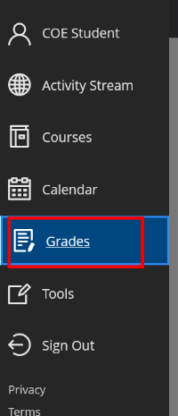

ALT TEXT: Left side navigation menu with Grades highlighted

1. Courses with the overall course grade are listed. Click **View all work** to access grades for course assignments.  
     
   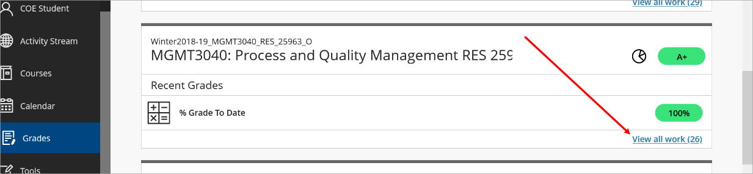

ALT TEXT: Course listed with an arrow pointing to View all work link

1. The ulearn My Grades page will open for the course selected.

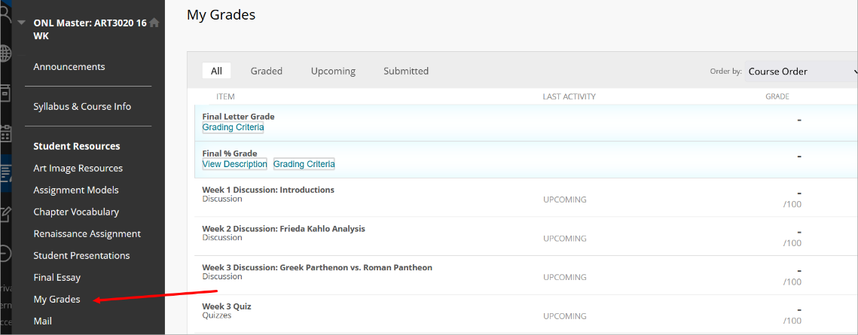

ALT TEXT: Course menu with an arrow pointing to My Grades

**Note:**

You can also access My Grades from the left course menu directly from the course.If My Grades does not appear on the left course menu, please contact your instructor as it may be hidden from students.

1. The My Grades top menu will sort grades by All, Graded, Upcoming, and Submitted.

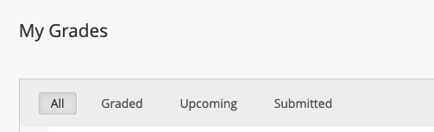

ALT TEXT: My Grades top menu

Click **All** to see all possible assignments in the course, including the Item name, Due Date, Rubric (if attached), Last activity (when the instructor graded it), and the Grade if it has been graded.

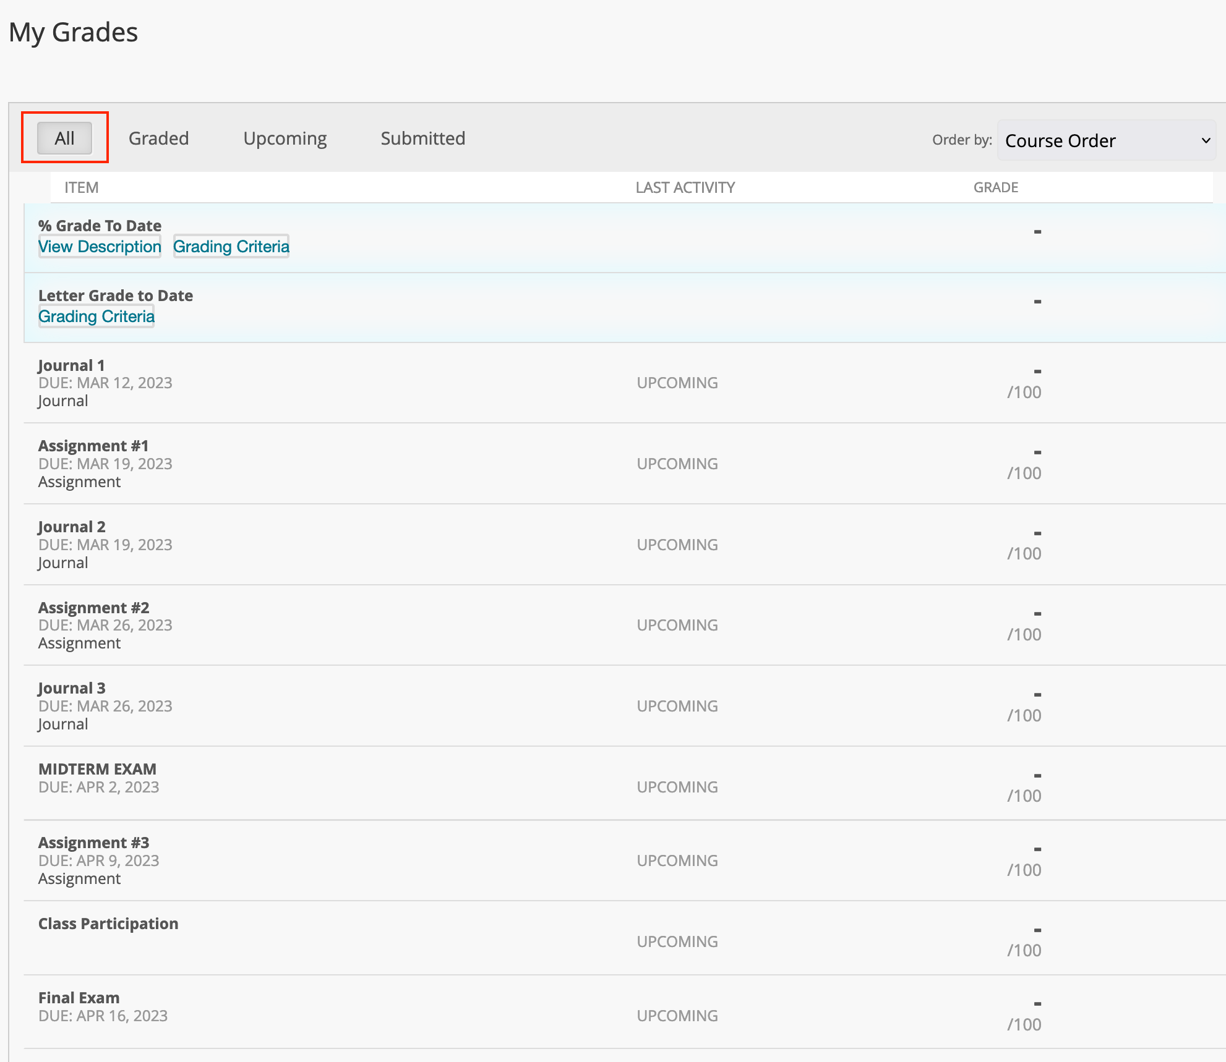

ALT TEXT: My Grades view with the All button highlighted

Click **Graded** to view only what your instructor has graded to date. You will see a blue bubble icon if your instructor left feedback on an assignment. Click on it to view the comment.

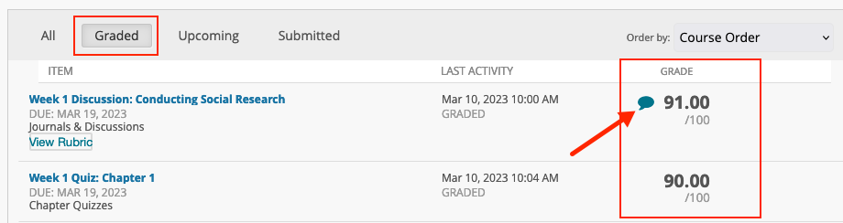

ALT TEXT: Graded assignments in My Grades view with feedback bubble

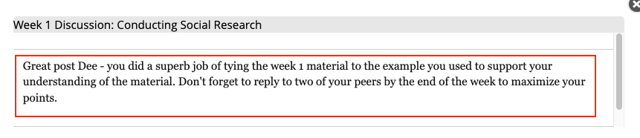

ALT TEXT: A view of a comment left for a student by the instructor on My Grades under an assignment.

Click **Upcoming** to view all upcoming assignments in the course. In the upper right part of the menu, you can sort the order by selecting your preferred order (Course Order, Last Activity, Due Date (Latest First), or Due Date (Oldest First).

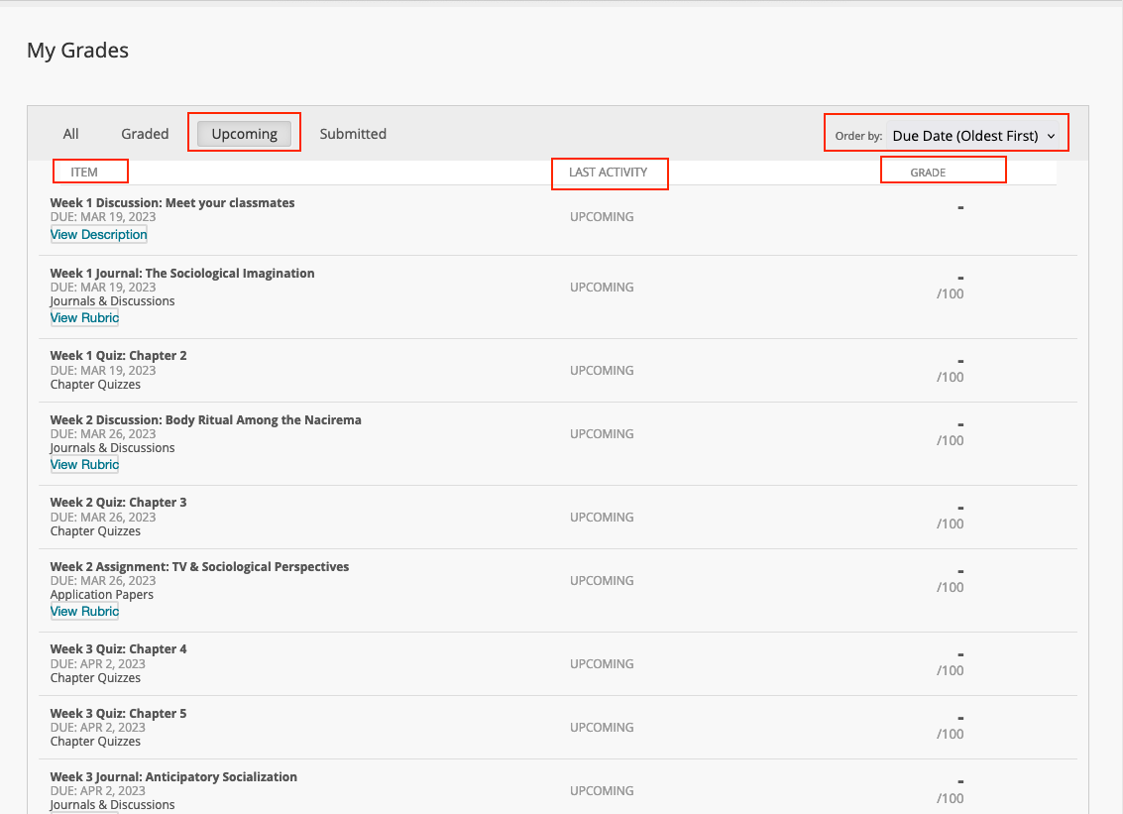

ALT TEXT: My Grades view of upcoming assignments

Click **Submitted** to view any assignments that have been submitted (but not graded yet by the instructor), including submission receipts attached to them, such as submitting any work to the Assignment tool in ulearn.

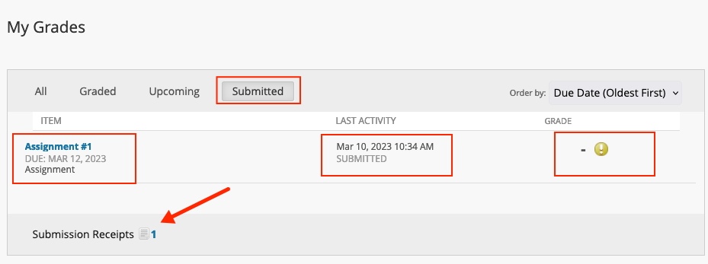

ALT TEXT: My Grades Menu - Submitted, which shows details about the assignment submitted, including a submission receipt

1. You can click on the **View Description** and/or **Grading Criteria** to view more information about how the grading criteria are set up in your course. This information should also match the syllabus of your course. Please talk to your instructor if these do not match.

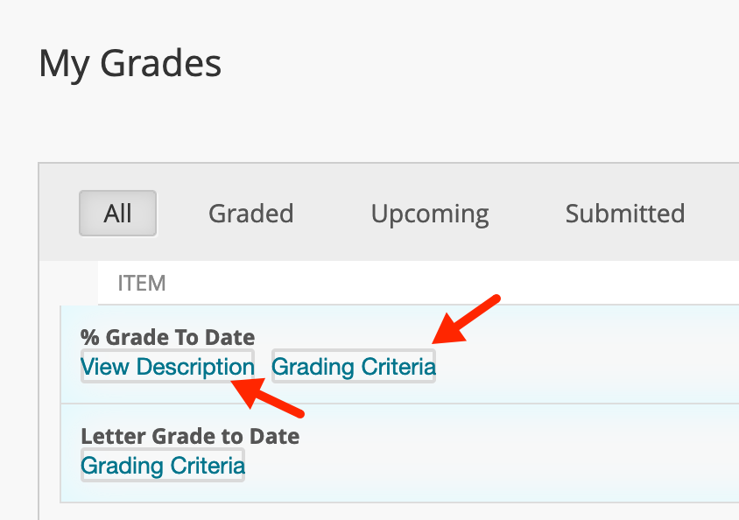

ALT TEXT: View Description and Grading Criteria can be clicked on for more information

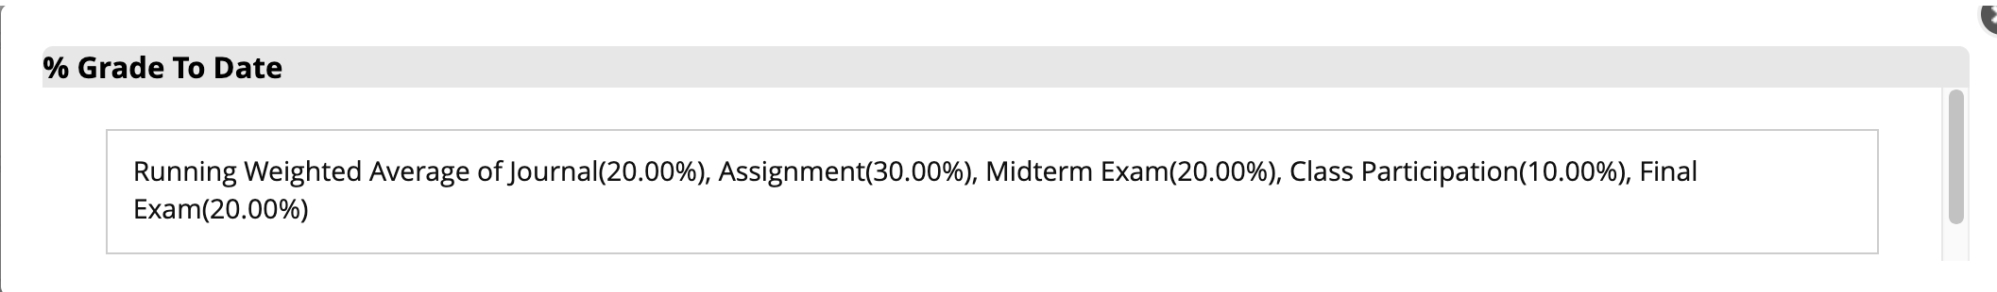

ALT TEXT: A breakdown of how the grade center is calculated.

1. To view Rubrics through My Grades, please [view this user guide.](https://idt.jwu.edu/ulearn/students/userguides/view_rubric_through_mygrades.pdf)
2. To view/review graded tests or quizzes in ulearn with the Test tool, please [view this user guide](https://idt.jwu.edu/ulearn/students/userguides/student_review_test.pdf).