To record narration over a presentation in PowerPoint you need Microsoft PowerPoint and a microphone.

Instructions

1. Open the presentation in PowerPoint.
2. From the menu bar, select **Slide Show** and click **Record Slide Show**.

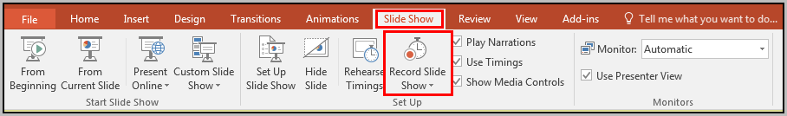

1. Select whether to start recording from the beginning or the current slide. The Record Slide Show box appears. Recording slide and animation timings remembers how long the narration runs for each slide. Make sure the **Narrations, ink and laser pointer** option is selected.



1. Click **Start Recording**. Speak into the microphone to record your voice. Click to advance each slide as you would if you were presenting live.

**Note:** To pause the narration, in the Recording shortcut menu in the upper left corner, click **Pause**. To resume narrating, click **Resume Recording.** You can also right click on a slide while narrating and select **Pause Recording** to pause and then resume your narration.

***Tip****To pause the narration, in the* ***Recording*** *shortcut menu in the upper left corner, click the* ***Pause*** *button. To resume your narration, click* ***Resume Recording****. You can also right click on a slide while you are narrating and select* ***Pause Recording*** *to pause your narration.*

***Tip****To pause the narration, in the* ***Recording*** *shortcut menu in the upper left corner, click the* ***Pause*** *button. To resume your narration, click* ***Resume Recording****. You can also right click on a slide while you are narrating and select* ***Pause Recording*** *to pause your narration.*

Enter Note here. Copy and Paste this box as necessary.

1. When finished recording the narration, right click the last slide and select **End Show**.
2. The recorded slide show timings are automatically saved and the slide show appears in Slide Sorter view with timings beneath each slide. Check the slide show to make sure everything recorded correctly. If you don't like the narration, click the bottom of the **Record Slide Show** button and use the Clear feature to remove narrations and timings and record again.
3. When the presentation is complete, **save** the PowerPoint.